MoU
Brief Technical & Functional Documentation

1. Project Overview
MoU stands for Memorandum of Understanding. It is a formal document that records an understanding or agreement between organizations/parties for a defined area of cooperation. The MoU Management System is a web-based application used to create, verify, endorse, approve and track MoUs through a controlled workflow.

2. Objective
- Digitize the MoU creation and approval process.
- Provide a single place to manage and track MoU records.
- Ensure each MoU follows the Initiator → Endorsing Agency → Approving Authority workflow.
- Maintain movement, comments/observations and important dates for tracking.

3. User Roles
Role | Brief Responsibility
Admin | Manage and track all MoUs and control master data.
Initiator | Create the MoU, fill required details and select the Endorsing Agency.
Endorsing Agency | Receive and verify the MoU. Endorse it if correct or send it back with an observation.
Approving Authority | Review the endorsed MoU and approve it or send it back with an observation.

4. Technology Used
Technology | Purpose
HTML / CSS | Page structure and styling.
Bootstrap | Responsive UI and standard UI components.
JavaScript / jQuery | Client-side functionality, validation and AJAX communication.
C# / .NET Core | Backend, business logic and application workflow.
SQL Server | Storage of MoU, workflow, comments, master and user data.

5. Main Functional Areas
- Login and role-based access.
- MoU creation and management.
- MoU movement and status tracking.
- Endorsement and approval processing.
- Observation/comment management.
- Master data management by Admin.

6. Database Overview
SQL Server is used as the application's database. The main transaction table is TrnMOU. Workflow movements are maintained in TrnMov and review observations are maintained in TrnComment. Supporting master data is maintained through mDomain and MAction.
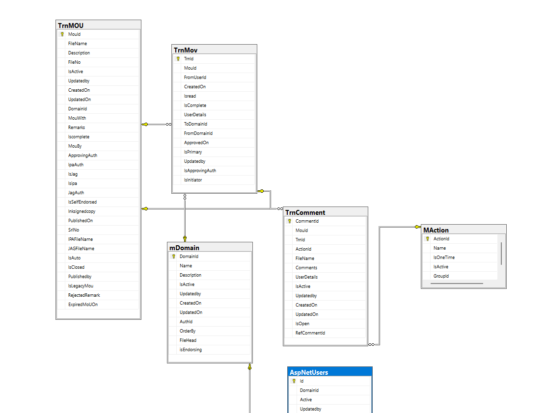
Figure 1: Main MoU database relationship diagram

7. Main Database Tables
Table | Purpose
TrnMOU | Main MoU transaction table. Stores MoU details, files, remarks, status/lifecycle flags, authority information and dates.
TrnMov | Stores MoU movement/workflow information such as source user, domains, action state and approval information.
TrnComment | Stores comments and observations linked to an MoU and its workflow movement/action.
mDomain | Master table for domain/organizational information used by the workflow.
MAction | Master table containing workflow action definitions.
AspNetUsers | Application user information used for authentication and user-related processing.

8. Key Relationships
- One MoU in TrnMOU can have multiple workflow movement records in TrnMov.
- A movement can have related comments/observations in TrnComment.
- TrnMov uses domain information from mDomain for source/destination routing.
- MAction defines the actions used during the MoU workflow.
- User-related fields connect workflow activity and comments with application users.

9. Application Architecture
The application uses a standard ASP.NET Core layered approach. The UI communicates with the .NET Core backend, the backend applies business rules and the data-access layer communicates with SQL Server.
Layer | Technology / Responsibility
UI Layer | HTML, CSS, Bootstrap, JavaScript and jQuery for screens and user interaction.
Controller Layer | ASP.NET Core controllers handle requests and responses.
Business Layer | C# services contain MoU workflow and business rules.
Data Access Layer | Handles database operations with SQL Server.
Database Layer | TrnMOU, TrnMov, TrnComment, mDomain, MAction and user tables.

10. Summary
The MoU Management System provides a controlled digital process for managing MoUs. The Initiator creates and submits the MoU, the Endorsing Agency verifies and endorses it, and the Approving Authority performs the final approval. If an issue is found, an observation can be recorded and the MoU returned for correction. SQL Server maintains the MoU, movement, comments, master and user information.

11. Conclusion
The system reduces manual MoU processing, improves visibility of pending and completed MoUs, clearly defines responsibility at each workflow stage and maintains a structured history of actions and observations.

